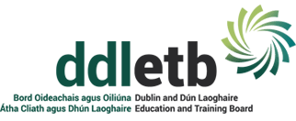
Danu Community Special School
c/o Hansfield ET Secondary School
Barnwell Road
Dublin 15
01 8270755
school@danucss.ie

School Calendar 2020/2021

School Reopens Monday 31st August 2020
October Mid Term
Closed Monday 26th October to Friday 30th October 2020

Christmas Holidays
Close at 12 noon Tuesday 22nd December 2020
Reopening Wednesday 6th January 2021

February Mid Term
Closed Thursday 18th February 2021
Closed Friday 19st February 2021

March St Patrick’s Day
Closed Wednesday 17th March 2021

Easter Closure
Close at 12 noon Friday 26th March 2021
Reopening Monday 12th April 2021

All schools will close on Friday 26rd March 2021, which will be the final day of the school term, unless changes are required as part of contingency arrangements to make up for time lost due to unforeseen school closures. Where contingency arrangements are required a school authority may reduce the length of the Easter break by remaining open up to and including Wednesday 31st March 2021.
May Bank Holiday
Closed Monday 3rd May 2021
June Bank Holiday
Closed Monday 2nd June – Friday 8th June 2021
Reopening Monday 11th June 2021

School will finish on Wednesday 30th June 2021 at 12 noon

